1. **Perform basic Image Handling and processing operations on the image. Read an image in python and Convert an Image to Blur using Gaussian Blur.**

**Aim:**

To Perform Basic Operations to Read Image and Convert to Blur using Gaussian Blur.

**Code:**

import cv2

import numpy as np

kernel = np.ones((5,5),np.uint8)

print(kernel)

path = r"C:\Users\prith\Pictures\Saved Pictures\cvimage.jpg"

img = cv2.imread(path)

imgGray = cv2.cvtColor(img, cv2.COLOR_BGR2GRAY)

imgBlur = cv2.GaussianBlur(imgGray, (7,7), 0)

cv2.imshow('Blurred Image', imgBlur)

cv2.waitKey(0)

cv2.destroyAllWindows()

**Input:**

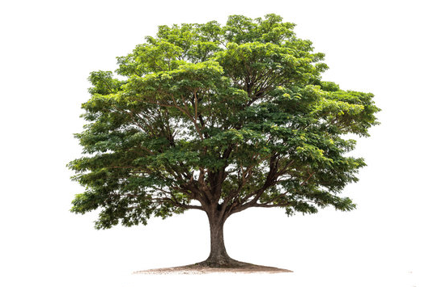

**Output:**

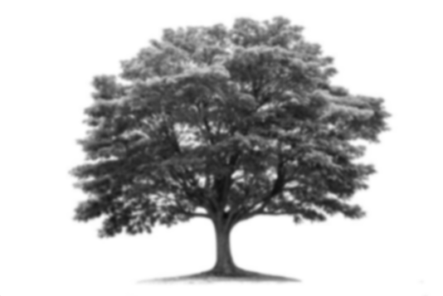

**Result:**

The python program to convert image to blur using gaussian blur.